

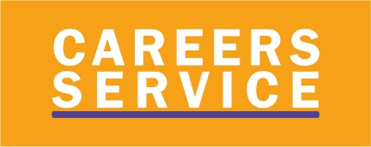

The Careers Adviser in Nendrum is Rosemary McKenna

@SkillstoSucceedNI
@Economy_NI
@Economy_NI

Year 12 Intro to the Careers Service Nidirect.gov.uk Options after year 12
Th

Nidirect.gov.uk Options after year 12

The Careers Service provides impartial careers information, advice and guidance to help you make informed choices about your future career path.
We understand this is an uncertain time but we are here to support you.
You can also use our live webchat or email an adviser - Contact Us.
To speak to a Careers Adviser call 07790986732
Th
Th

Our helpline is open Monday to Friday, 9:30am-4:30pm.
Our Careers Service Website has lots of help and advice.
Get started by trying out our Careers Online Tools and check out our Young Persons Guide.

